Personal Profile
for Year 11 students
in 2023

Student Name: _____________________________________________________________________

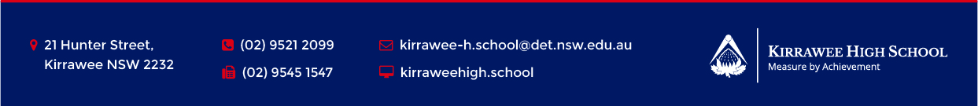
1. | What are my goals/ambitions over the next two years?
2. | What subjects have I done well in this year? Why?
3. | What were the positives of my Year 10, Semester 1 report?
4. | Were there any suggestions about how to improve? What were they?
5. | Describe any subject interests that I need to express at my interview.

6. | What contributions have I made to the wider life of school in Years 7-10?
7. | What kind of attitudes, behaviours and practices do I need to leave behind from Years 7-10?
8. | What areas do I really need to work on to make Year 11 and 12 fulfilling and successful?

