

**Personal Profile**

**for Year 11 students**

**in 2025**

Student Name: _____________________________________________________________________

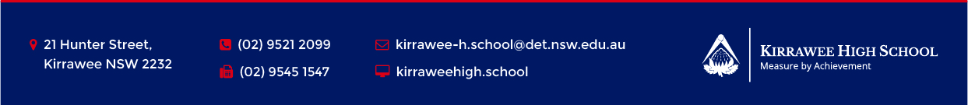

1. What are three goals/ambitions over the next two years or when leaving school?

|  |  |  |
| --- | --- | --- |
|  |  |  |

2. What subjects have I done well in this year? Why?

…………………………………………………………………………………………………..

…………………………………………………………………………………………………..

…………………………………………………………………………………………………..

…………………………………………………………………………………………………..

3. What are your five strengths identified in the MyStrengths workshop?

|  |  |  |  |  |
| --- | --- | --- | --- | --- |
|  |  |  |  |  |

4. Did my School report make suggestions about how to improve? What were they?

…………………………………………………………………………………………………..

…………………………………………………………………………………………………..

…………………………………………………………………………………………………..

…………………………………………………………………………………………………..

5. Are there any specific subject requirements (prerequisites, recommended or assumed knowledge) for any tertiary (after school) studies or apprenticeships you would like to undertake?

Hint: Look at the information on your Year Group Google classroom for how to look up course requirements on the UAC and TAFE websites.

…………………………………………………………………………………………………..

…………………………………………………………………………………………………..

…………………………………………………………………………………………………..

…………………………………………………………………………………………………..

6. What contributions have I made to the wider life of school in Years 7-10?

…………………………………………………………………………………………………..

…………………………………………………………………………………………………..

…………………………………………………………………………………………………..

…………………………………………………………………………………………………..

7. What are three attitudes, behaviours and practices I need to leave behind from Years 7-10?

* ……………………………………………………………………………………………..
* ……………………………………………………………………………………………..
* ……………………………………………………………………………………………..

8. What are three areas I really need to work on to make Year 11 and 12 fulfilling and successful?

* ……………………………………………………………………………………………..
* ……………………………………………………………………………………………..
* ……………………………………………………………………………………………..